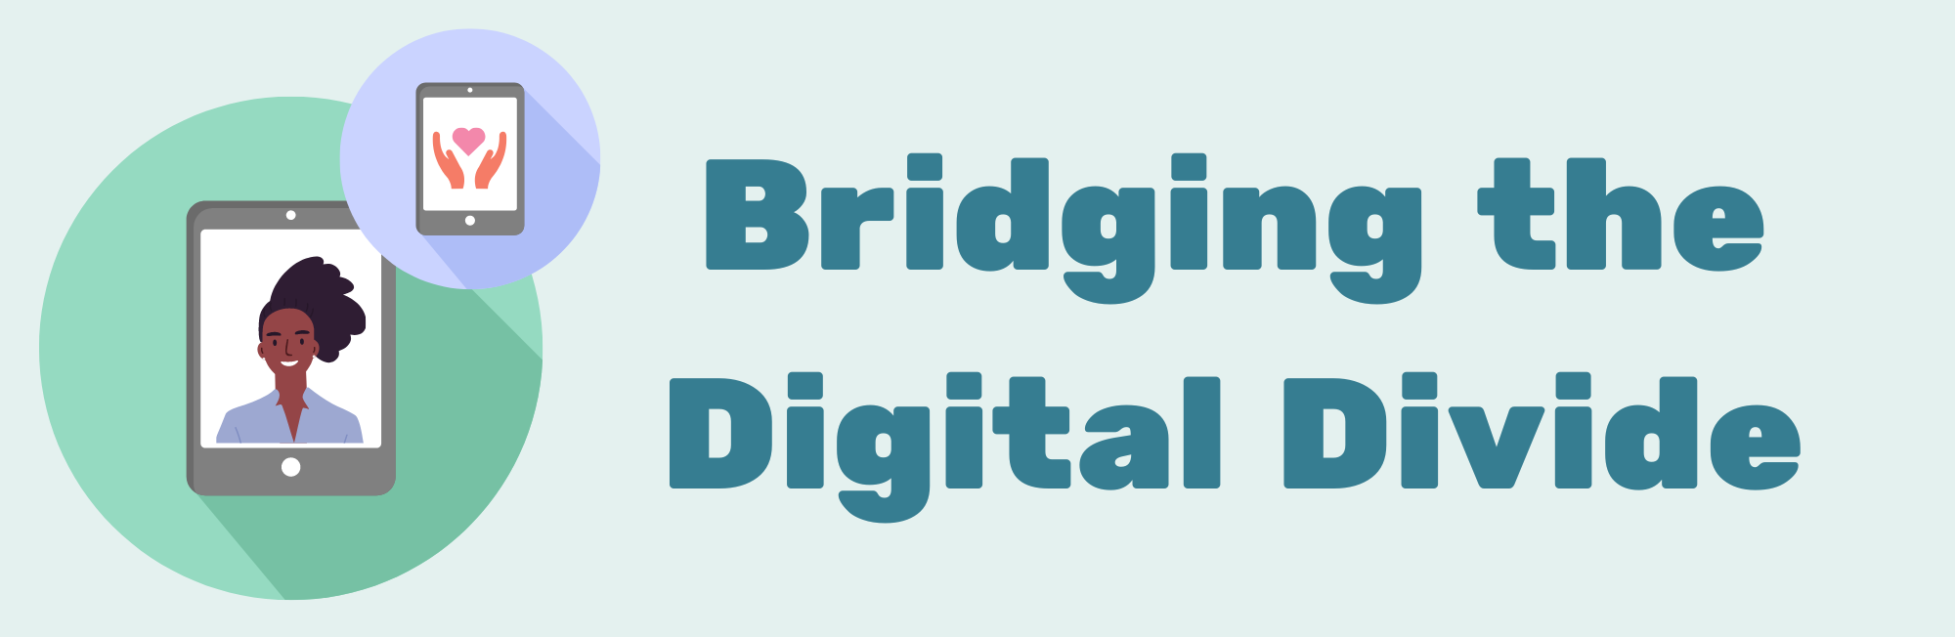

Join our exciting new professional development program to help your community get online
Learn practical skills and access exclusive training resources to support young people with an intellectual disability to get online more safely and confidently.
Did you know 1 in 4 people in Australia are digitally excluded? This means they do not have the affordable access, skills or confidence to use the internet for everyday tasks. People with disabilities are more likely to experience the digital divide, and may need additional support to get online.

This is a problem that can be solved.

Everyone has the right to get online safely and confidently, and have the friendly, local support they need to do so. That’s why we have created this professional development program for community workers and volunteers supporting young people with intellectual disability.

How this program will help you
By participating in this program you will:
- Attend 1 online professional development workshop to receive essential training (1 June 2023)
- Provide free practical digital skills support to 5 young people with intellectual disabilities in your community using our learning resources to build your practical skills
- Capacity build 5 parents / carers of young people with intellectual disability by informing them about this program and supports available to develop your practical community engagement skills
- Receive a tailored learning support phone call to support your learning and participation
- Attend 1 online reflective practice workshop to embed your learnings (November 2023) and report back on your experience in the program.

By participating in this program, you will help us develop our training and support resources to create best practice, free support for anyone with intellectual disabilities who wants to learn, while gaining practical digital mentoring skills yourself.

Program outcomes
By participating in this program you will:
- Gain practical skills in digital mentoring young people with intellectual disabilities applicable to your organisation and community context
- Access tailored, ready-to-use resources
- Receive individual support for your learning and program
- Gain a network of practitioners to share learnings and experience
- Support your community of young people with intellectual disability to get online more safely and confidently.

Time commitment
The two online workshops will take 4 hours in total.
We suggest you allocate 15-20 hours for independent learning, reflection, and providing practical support in your community using the training/resources (depending on your organisation and how you choose to implement the training/resources you have received).
You will have 6 months to complete the program (June - November 2023).

Cost
Free
Your organisation must be registered as part of Good Things Foundation’s national digital inclusion network to access this free training program. This network is free to join. Membership also gives your organisation access to digital inclusion grant funding, resources, training and support.

How to get involved
To get involved, express your interest by Friday 5 May 2023 by completing the online application form. If you need support to access this information or form, please contact our support team on (02) 9051 9292 or connect@goodthingsfoundation.org

Express your interest: www.beconnectednetwork.org.au/bridging
This program is being run by Good Things Foundation Australia with the support of Down Syndrome Australia. Find out more about us:
www.goodthingsfoundation.org.au
www.downsyndrome.org.au

