Session Plan: Connecting safely with others online

Delivery mode:
Face to face delivery

Session overview:
This session will provide learners who are new to the internet with some practical tips to stay safe online when they are connecting with family and friends.

Learning objectives:
Learners will:
- feel safer when they are online
- know more about online stranger danger
- know what is ok to share online and what they should keep private

Suggested session length:
This session should run for approximately 2 hours. The facilitator to schedule breaks as required.

Facilitator Tips:
- This session is best delivered using a data projector and screen to allow all learners to follow along.
- As some learners may not be confident or able to read, you may be required to read the material out loud. Encourage the learners to follow along using their own device.
- Each learner must access their own device for this session.
- Do a test run of the session including the activities and using the videos to ensure you are familiar with the content. Open the videos in separate tabs so they are ready to be shown.
- To adjust the volume, activate closed captions or to slow the speed of Youtube videos refer to the screenshots below.

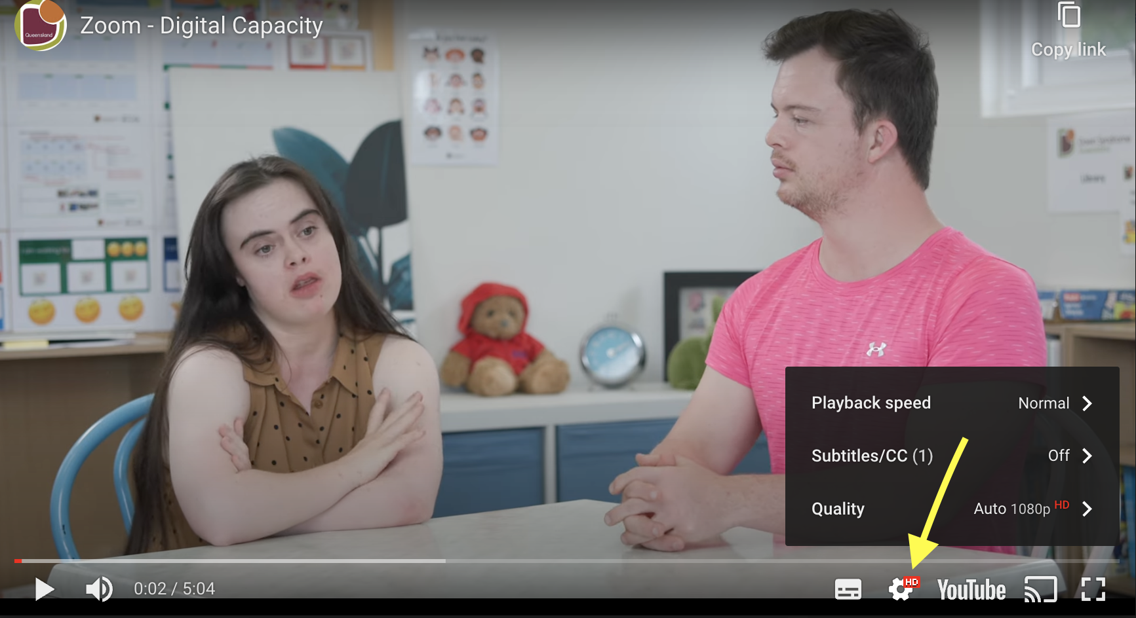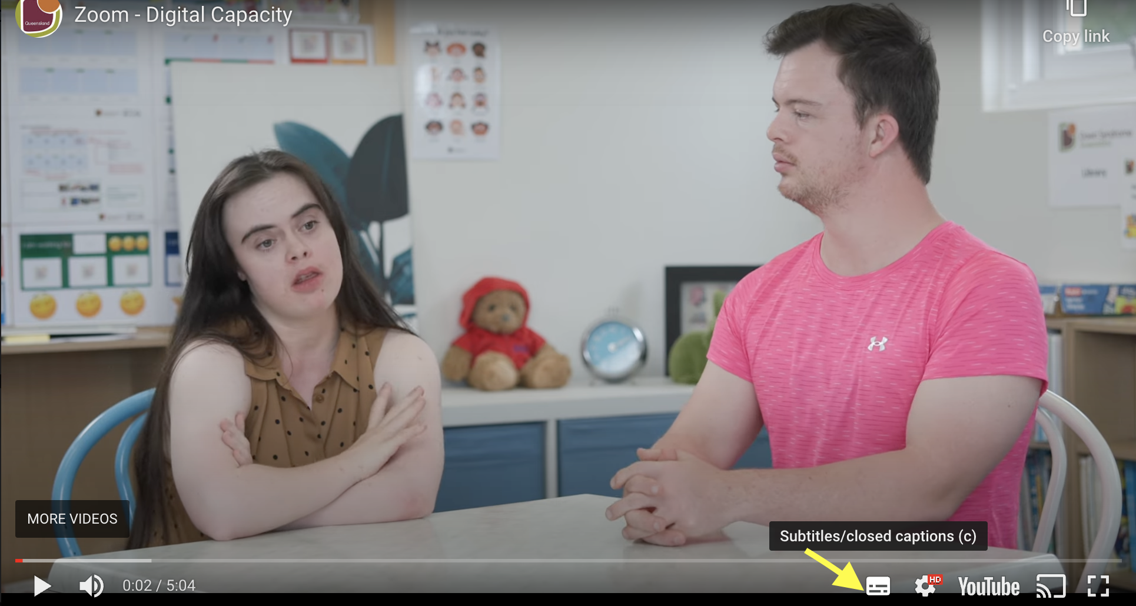

- Pausing videos will allow learners to catch up and provide an opportunity for discussion.
- Acknowledge with the group it is ok to have concerns about using the internet, especially if the learner is new to being online. Common concerns include ‘how do I stay safe’, ‘how can I protect myself from online bullying’, ‘how can I maintain my privacy’ and ‘being appropriate on the internet’.

Other courses in this series
- Using email
- Video calling

Topic | Timing | Activity | Assessment | Resources
Introduction & welcome  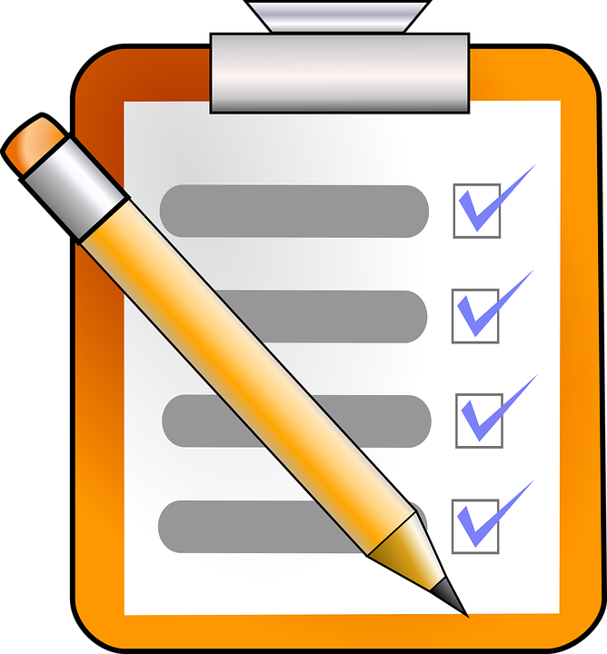 | 10 mins | Facilitator to:  - introduce themselves  - confirm all learners are set up online  - remind learners to do as much as they can by themselves  - discuss the learning objectives  - discuss how the session will run  - remind learners to raise their hand to gain facilitator attention.  Activity 1 - Icebreaker  Learners introduce themselves and share 1 thing that excites them about being online  Facilitator to acknowledge and write up on the whiteboard and discuss. | All learners engage | Training venue  Refreshments  Laptop or PC, data projector and screen  Learners to each have access to an internet connected device  Link to online module -  Connecting Safely Online  Printable Learner Workbook  Notepads / Pens  Whiteboard / marker pens
Online module | 40 mins | Facilitator to confirm all learners can access the online module - Connecting safely online.  Activity 2 - Connecting Safely Online learning course  Encourage learners to begin the online module and to work their way through the material at their own pace.  Ask the learners to make notes of key points for discussion.  Remind learners and their carers they can talk to you if they have any questions about the material.  Consider walking round the room asking learners how they are getting on as they may need reassurance or want to ask questions.  Ask the learners to close the online course once they have finished. | Learners engage at their own pace.  Take notes in printable learner workbook. | Online module - Connecting Safely Online  Notepad / pen  Links to videos  - How do you connect with others online?  - Online stranger danger  - What is a scam email?
Break | 10 mins | Encourage learners to have a break, stretch their legs and have a drink if needed.
Activities / Recap | 20 mins | Activity 3 - Shared learning & recap  Facilitator to ask each learner to share 1 -2 things they have learnt from the online module.  Facilitator to lead a discussion on the items raised and ensure learners cover the key points of the online module. | All learners participate | Connecting Safely top tips handout
Group discussion | 10 mins | Activity 4 - Online Strangers  Learners to write on a post-it note one (1) online behaviour used by online strangers. Encourage learners to think of as many answers as possible.  Facilitator to display Post - It notes on the whiteboard and facilitates a discussion filling in the gaps if required. | All learners participate | Post it notes  Marker pens
Group discussion & flipcard activity | 10 mins | Activity 5 - Recap What is OK to share online  Group activity - Using the flipcards cards, ask learners to look at the images. The aim of this activity is for the learners to decide which of the 2 groups (Yes ok to share / No, not ok to share) the images are placed in.  Allow the learners to complete this activity as a group and then go to each pile of cards and check their responses. Rectify and discuss card placement if required. | All learners participate | Printable A4 Flipcard activity resource
 | 10 mins | Activity 6 - Reflection  Facilitator to ask learners if they can remember the things they can do to help keep them safer online.  Facilitator to ask learners if they feel safer and more confident now being online.  Restate the people they can trust online include, family, friends and support persons. | Learners all participate | Connecting Safely Online Course Feedback form
 | 10 mins | Activity 7 - Evaluation form  Facilitator to ask the learners to complete and return the workshop evaluation form.  Provide learners with certificate of completion to celebrate their success. | All learners participate | Workshop Evaluation form  Certificate of completion

