Session Plan: Using email

Delivery mode:
Face to face delivery

Session overview:
This session will provide learners with practical tips on how to use email.

Learning objectives:
By the end of the session learners will be able to

- Know more about how emails work
- Feel more confident sending emails
- Feel safer when using emails

Suggested session length:
This session should run for approximately 2 hours. The facilitator to schedule regular breaks as required.

Facilitator Tips:
- Each learner must have access their own device for this session.
- This session is best delivered using a data projector and screen to allow all learners to follow along.
- As some learners may not be confident or able to read, you may be required to read the material out loud. Encourage the learners to follow along using their own device.
- Learners may need headphones if they choose to listen to the online course using the Text to Voice facility.
- Do a test run of the session including the activities and using the videos to ensure you are familiar with the content. Open the videos in separate tabs so they are ready to be shown.
- To adjust the volume, activate closed captions or to slow the speed of Youtube videos refer to the screenshots below.

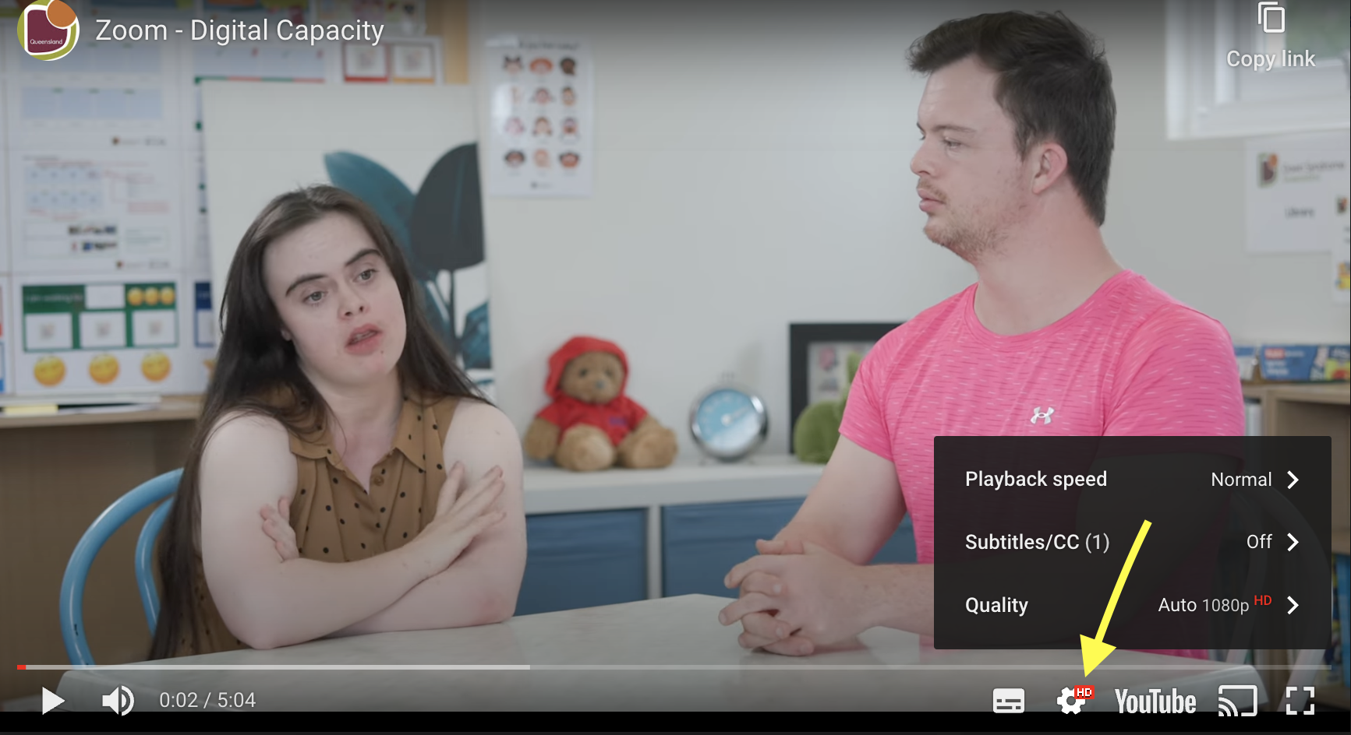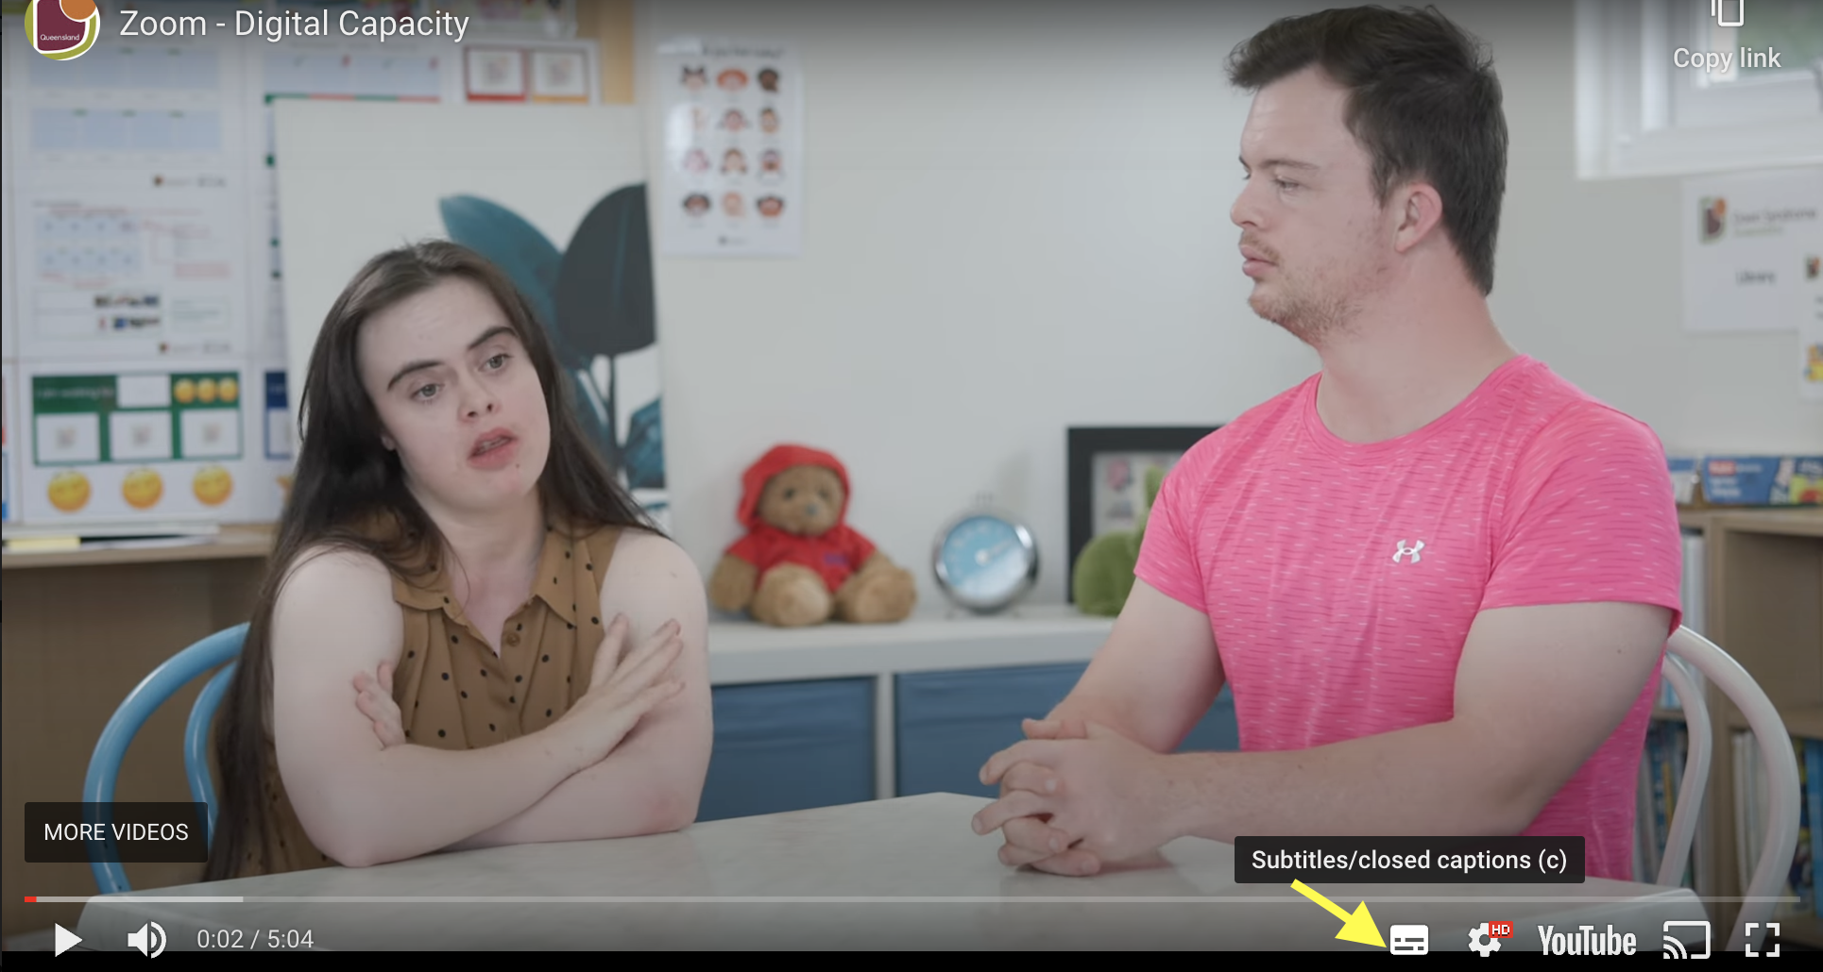

- Pausing videos will allow learners to catch up and provide an opportunity for discussion.

Other courses in this series
- Connecting safely online
- Video calling

Topic | Timing | Activity | Assessment | Resources
Introduction & welcome  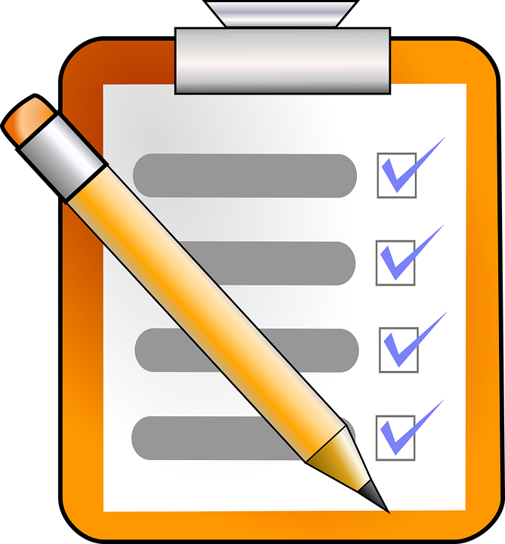 | 10 mins | Facilitator to:  - introduce themselves  - confirm all learners have their devices set up  - remind learners to do as much as they can by themselves  - discuss the learning objectives  - discuss how the session will run  - remind learners to raise their hand to gain facilitator attention.  Activity 1 - Icebreaker - What made you smile today?  Learners to introduce themselves.  Facilitator asks the question, What made you smile today?  Each learner shares the one thing that made them smile. Repeat until all learners have had a turn. | All learners engage | Training venue  Refreshments  Laptop or PC, data projector and screen  Learners to each have access to an internet connected device  Link to online course - Using email.  Printable Learner Workbook  Notepads / Pens  Whiteboard / marker pens  What made you smile - Icebreaker Activity resource
Online course | 40 mins | Facilitator to confirm all learners can access the online course - Using email.  Activity 2 - Using email online learning course  Learners to commence the online course and to work their way through the material at their own pace.  Ask the learners to make notes or draw a picture of the key points they wish to discuss after the break.  Remind learners and their support person they can talk to you if they have any questions about the material.  Consider walking round the room asking learners how they are getting on as they  may need reassurance or want to ask questions.  Ask the learners to close the online course once they have finished. | Learners engage at their own pace.  Note taking in printable learner workbook | Link to online course - Using email.  Printable Learner Workbook  Notepad / pen  Links to videos used in online course:  - What do you use email for?  - What is a scam email?  - What do you do when you get a spam email?
Break | 10 mins | Encourage learners to have a break, stretch their legs and have a drink if needed.
Discussion & Recap | 20 mins | Activity 3 - Shared learning  Facilitator to ask each learner to share 1 -2 things they have learnt from the online course.  Facilitator to ask if the learners noted down any key points they learnt during the online course they wish to discuss now.  Facilitator to recap the following  - How to create an email account  - Composing and sending an email  - Recognising Spam email  - Replying to an email  - Attachments | All learners participate. | Laptop , PC  Post it notes  Marker pens  Using emails top tips handout
 | 20 mins | Activity 4 - Composing, sending and replying to an email  Share your professional email with the learners. Then ask the learners to compose and send you a short email.  The facilitator is to reply to email, such as with message:  “Well done. Thank you for your email. I can see you can compose and send emails. Can you open the attachment? Reply to this email and tell me what is in the attachment.” | All learners participate. | Composing, Sending & Replying to Email Activity Resource.
Group discussion | 10 mins | Activity 5 - Reflection  Facilitator to ask learners if they can recall what a Spam email can look like. Discuss. | All learners participate.
Evaluation and close | 10 mins | Activity 6 - Evaluation form  Facilitator to ask the learners to complete and return the online / hard copy evaluation form.  Provide learners with certificates of completion to celebrate their success. | Learners all participate | Using email online course evaluation form  Workshop Evaluation form  Certificate of Completion

