Session Plan: Video calling

Delivery mode:
Face to face delivery

Session overview:
This session will provide learners with practical tips on how to safely use video calling.

Learning objectives:
By the end of the session learners will

- know more about using the microphone and camera in a video call
- feel safer when you are video calling
- know more about being respectful to others in video calls.

Suggested session length:
This session should run for approximately 2 hours. The facilitator to schedule regular breaks as required.

Facilitator Tips:
- Each learner must have access to their own device for this session.
- This session is best delivered using a data projector and screen to allow all learners to follow along.
- As some learners may not be confident or able to read, you may be required to read the material out loud. Encourage the learners to follow along using their own device.
- Learners may need headphones if they choose to listen to the online course using the Text to Voice facility.
- Do a test run of the session including the activities and using the videos to ensure you are familiar with the content. Open the videos in separate tabs so they are ready to be shown.
- To adjust the volume, activate closed captions or to slow the speed of Youtube videos refer to the screenshots below.

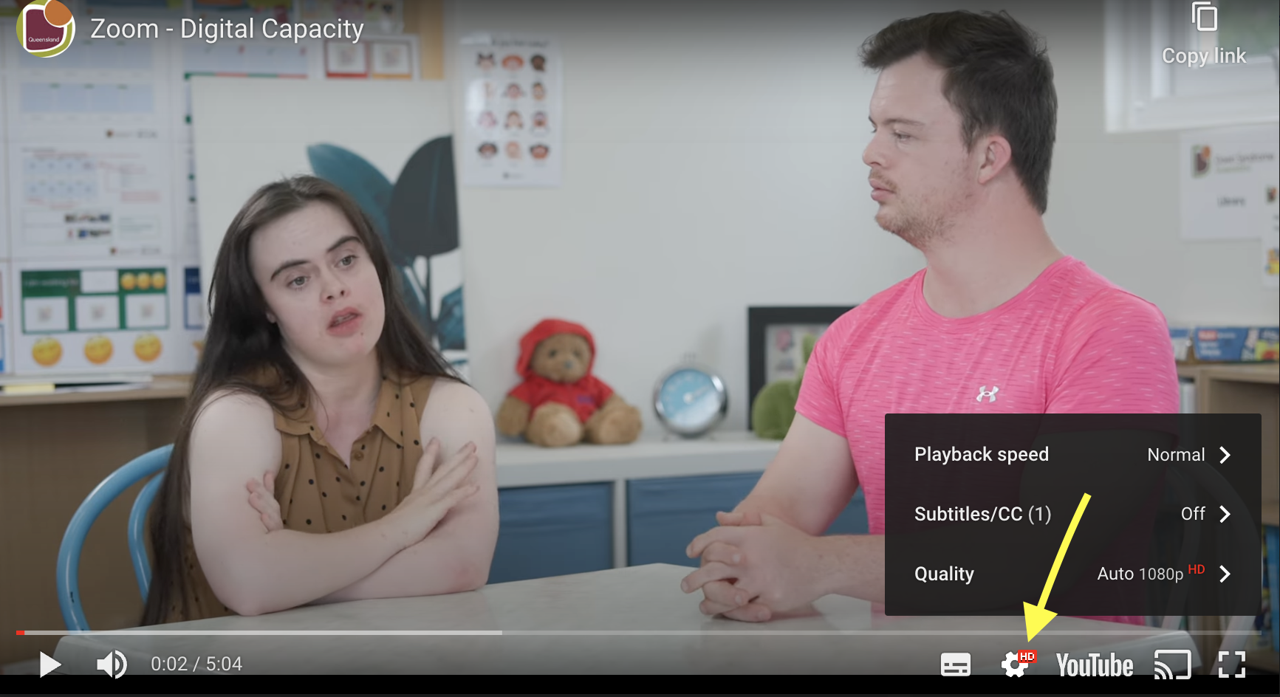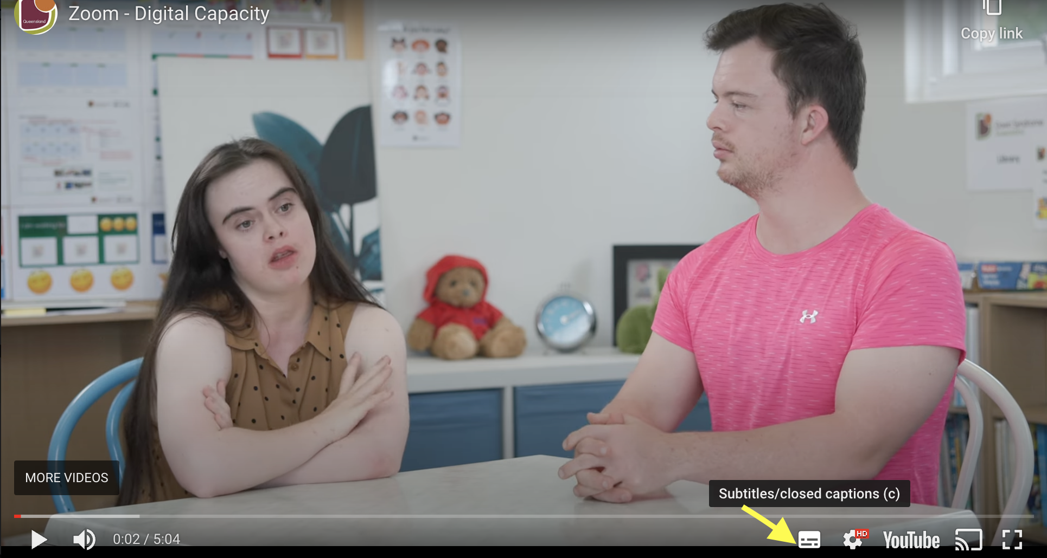

- Pausing videos will allow learners to catch up and provide an opportunity for discussion.

More courses in this series:
- Connecting safely online
- Using emails

Topic | Timing | Activity | Assessment | Resources
Introduction & welcome | 10 mins | Facilitator to:  - introduce themselves  - confirm all learners have their devices set up  - remind learners to do as much as they can by themselves  - discuss the learning objectives  - discuss how the session will run  - remind learners to raise their hand to gain facilitator attention.  Activity 1 - Icebreaker The Stinky Fish  Learners introduce themselves and share 1 thing that worries them about being online. The 1 thing is a metaphor for the Stinky Fish. The longer you hold onto the worry the smellier and harder it is to overcome.  Facilitator to recognise the concerns (stinky fish) raised and discuss summarising the key themes on the whiteboard. This will assist in normalising learners' concerns. | All learners engage | Training venue  Refreshments  Laptop or PC, data projector and screen  Learners to each have access to an internet connected device  Video Calling online module  Learner Workbook Video Calling  Notepads / Pens  Whiteboard / marker pens  Stinky Fish Icebreaker Exercise
Online course | 40 mins | Facilitator to confirm all learners can access the online course - Video calling.  Activity 2 - Video Calling online module  Learners to commence the online course and to work their way through the material at their own pace.  Ask the learners to make notes or draw a picture of the key points they wish to discuss after the break.  Remind learners and their support person they can talk to you if they have any questions about the material.  Consider walking round the room asking learners how they are getting on as they  may need reassurance or want to ask questions.  Ask the learners to close the online course once they have finished. | Learners engage at their own pace.  Discussions with support person | Video Calling online module  Learner Workbook Video Calling  Notepad / pen  Links to videos used in online course:  - What can you do on Zoom  - How do you turn your camera off or on  - What should you not share online?  Video calling online course evaluation form
Break | 10 mins | Encourage learners to have a break, stretch their legs and have a drink if needed.
Discussion & Recap | 20 mins | Activity 3 - Shared learning  Facilitator to ask each learner to share 1 -2 things they have learnt from the online course.  Facilitator to ask if the learners noted down any key points they learnt during the online course they wish to discuss now.  Facilitator to recap the following  - Block calls from people you do not know.  - There are different video calling apps available  - Use headphones to reduce noise and to maintain privacy  - How to ensure your privacy on video calls | All learners participate. | Laptop , PC, tablet or smartphone  Marker pens  Video calling top tips handout
Practical | 20 mins | Activity 4 - Video call practice  Ask the learners to video call another person in the group.  Facilitator to walk around the room and ensure all learners are using headphones, camera is positioned appropriately and offer support where required. | All learners participate. | Learners have their own device  Choose a free video calling app learners will use.
Discussion | 10 mins | Activity 5 - Reflection  Facilitator to ask learners if they can recall how they can maintain their privacy on a video call. | Learners all participate
Evaluation and close | 10 mins | Activity 6 - Evaluation form  Facilitator to ask the learners to complete and return the online / hard copy evaluation form.  Provide learners with certificate of completion to celebrate their success. | Learners all participate | Overall workshop evaluation form  Certificate of completion

