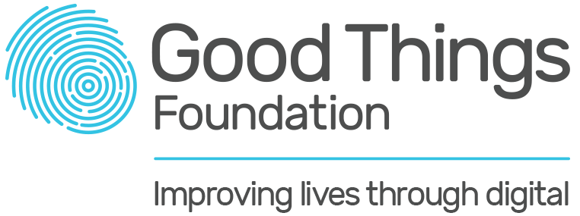

VIDEO/PHOTO RELEASE FORM

As a leader in digital and social inclusion, Good things Foundation uses a range of mediums to promote our impact within the community. Such mediums include:
  - Print publications (magazines, newspapers, journals)
  - Television and online video
  - Radio
  - Online platforms (webpages, social media)
  - Promotional materials and advertising

Any image, recording or document pertaining to your involvement is taken, used and stored in accordance with current legislation. Please contact Good Things Foundation at connect@goodthingsfoundation.org if you have any questions.

Do you give permission for your image to be used by Good Things Foundation as outlined above?
Yes [ ] No [ ]

Signature _________________________________________________________________

Name ____________________________________________________________________
Date _____________________________________________________________________
Email Address (optional) _____________________________________________________

Thank you!

