Your Health in Your Hands - Network Partner Social Media Communications Guide

This helpful guide, alongside the resources on the Be Connected Network website, will give you everything you need to promote your Your Health in Your Hands program on social media.

Contents
Top tips for using this guide 1
Twitter Social Posts 2
Social media tiles 2
Twitter post - Announcing your Your Health in Your Hands Program 2
Twitter post - Promoting your in-person support sessions 3
LinkedIn Posts 3
LinkedIn post - Announcing your Your Health in Your Hands Program 3
Facebook Posts 4
Facebook media tiles 4
Facebook post - Announcing your Your Health in Your Hands Program 5
Facebook post - Promoting your in-person support sessions 5
More promotional resources 5

Top tips for using this guide

- The below templates contain sections where you will need to fill in your own information. These sections are [highlighted in yellow and brackets].

- Remember! If you tag us when mentioned in the below templates, we can help share your posts! Just put the @ symbol directly before our name (e.g. @Good Things Foundation Australia on Facebook and LinkedIn; @goodthingsaus on Twitter) and we’ll get an alert when you post!

Twitter Social Posts

Social media tiles
Download full-resolution Twitter tiles on the Be Connected Network website. Samples are included below - feel free to choose the option that best suits your learners!

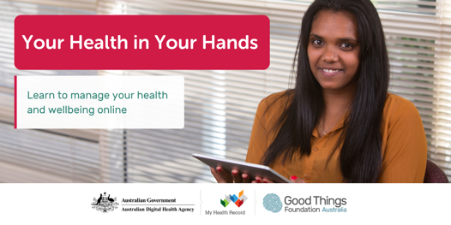 | 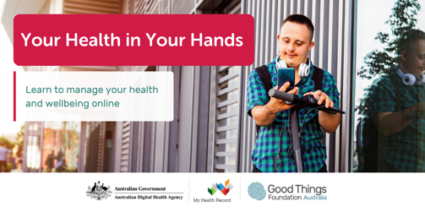
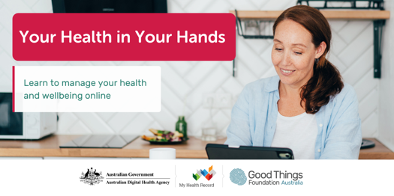 | 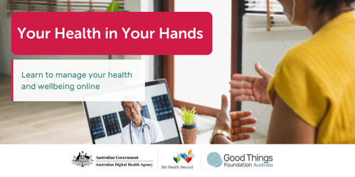
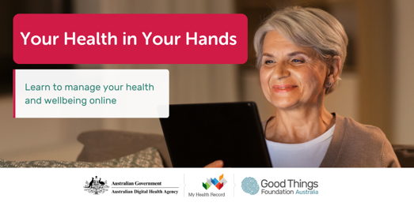 | 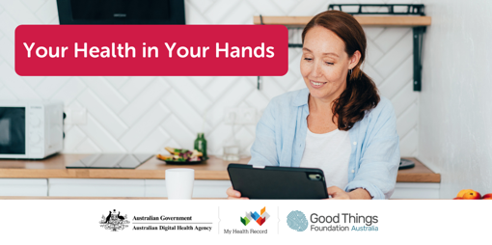

Twitter post - Announcing your Your Health in Your Hands Program

Take control of your own health information - access what you need, when you need it. Through the #YourHealthInYourHands program, we’re running free support sessions to help you manage your health using secure and reliable online tools.

Learn more: [LINK TO YOUR WEBSITE PAGE WITH MORE INFORMATION]

Twitter post - Promoting your in-person support sessions
Attend our FREE in-person support session on [DATE/TIME] to learn more about [TOPIC HERE].

➡️ Sign up now and learn more: [LINK TO YOUR WEBSITE PAGE WITH MORE INFORMATION]
#YourHealthInYourHands

LinkedIn Posts

LinkedIn post - Announcing your Your Health in Your Hands Program
We’re proud to announce that [YOUR ORGANISATION NAME] is a delivery partner for the Your Health in Your Hands digital health literacy program!

We’ve seen how important digital health skills are for our community, especially during the pandemic. Immunisation records, test results, electronic prescriptions, and booking health care appointments are now all done online, giving people the opportunity to have equal access to health services where and when they need. But people with low confidence using online tools and technology are missing out and risk being left behind.

That’s why we are running in-person support sessions to help our community improve their digital skills and feel confident and safe using online technology to manage their health information and services. We’ll be running free Your Health in Your Hands support sessions from [FIRST SESSION DATE].

Find out more about our Your Health in Your Hands program: [LINK TO YOUR WEBSITE PAGE WITH MORE INFORMATION OR CONTACT INFORMATION]

We’re joining other community organisations around Australia running Your Health in Your Hands support sessions, coordinated by Good Things Foundation Australia in partnership with the Australian Digital Health Agency.

#DigitalHealth #DigitalSkills #YourHealthInYourHands #DigitalLiteracy #DigitalHealthLiteracy

Facebook Posts

Facebook media tiles

Download full-resolution Facebook tiles on the Be Connected Network website. Samples are included below - feel free to choose the option that best suits your learners!

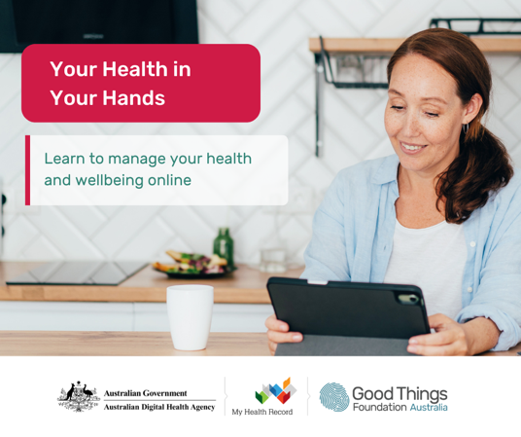 | 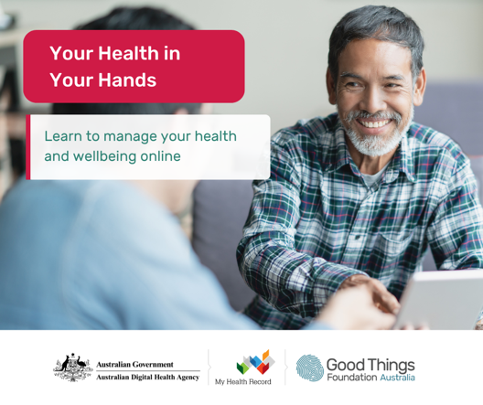
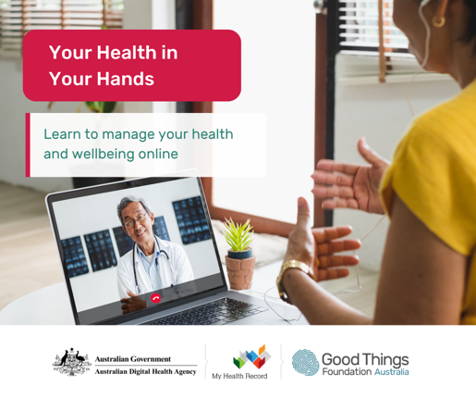 | 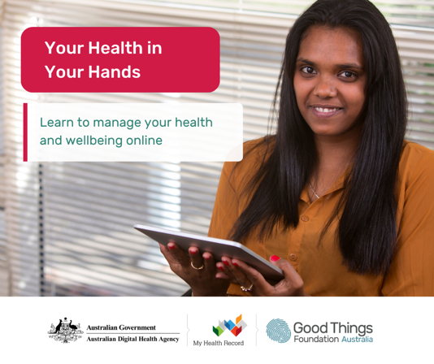

Facebook post - Announcing your Your Health in Your Hands Program

New free digital skills program to help you manage your health online coming to [YOUR ORGANISATION NAME]!

From [FIRST SESSION DATE], we’ll be running free in-person support sessions to show you how easy, convenient and safe managing your health online can be. Our ‘Your Health in Your Hands’ support sessions will teach you how to manage your health information and services securely and with confidence online using reliable websites and services.

Find out more about our Your Health in Your Hands sessions: [LINK TO YOUR WEBSITE PAGE WITH MORE INFORMATION OR CONTACT INFORMATION].

We’re proud to be delivering the Your Health in Your Hands program in our community. The program is coordinated nationally by Good Things Foundation Australia in partnership with the Australian Digital Health Agency.

Facebook post - Promoting your in-person support sessions

Want to know how to [TOPIC HERE]?

Attend our FREE in-person support session on [DATE/TIME] to learn more about [TOPIC HERE].

➡️ Sign up now and learn more: [LINK TO YOUR WEBSITE PAGE WITH MORE INFORMATION OR CONTACT INFORMATION].

We’re delivering this session and more as part of the Your Health in Your Hands program, a free program to help increase digital skills so everyone can manage their health information online with confidence. Your Health in Your Hands is coordinated nationally by Good Things Foundation Australia in partnership with the Australian Digital Health Agency.

More promotional resources
We have plenty of other resources to help you promote your program to your community, such as posters available on the Be Connected Network website.

